www.comics-4-kids.org 206.327.7436 comics4kids@aim.com

13 points of Appraisal
- Evaluation
- Authentication
- Corroboration
- Value
- Liquidity
- Volatility
- Grade Assignment
- Restoration Level
- Pop Culture Status
- Cross-over interest
- Character longevity
- Archival Method(s)
- Dissertation

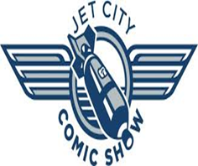
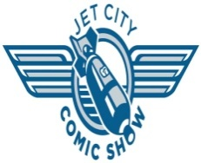
Comics4Kids © 1996- 2014 Comics4kids, Inc. All rights reserved Wizard World © 2014 Wizard World Used with Permission
Emerald City Comic Con © 2014 Emerald City Comic Con Used with Permission Rose City Comic Con © 2014 Rose City Comic Con Used with Permission Jet City Comic Show © 2014 Jet City Comic Show Used with Permission

