www.comics4kidsinc.org (206) 327 7436 comics4kids@aim.com
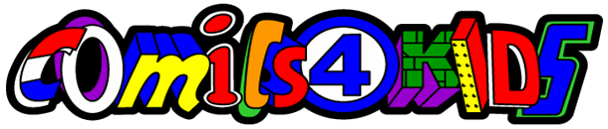
EIN 20-2882260 UBI 603201653

Why Graphic Novels & Comics?
"The presence of comics in a junior high school library resulted in a dramatic 82% increase in library traffic and a 30% increase in circulation of non-comic books."
Dorrell & Carroll School Library Journal
Graphic novels & comic books... Are a time-honored American literary art form that can:
- Broaden & strengthen library collections.
- Attract new readers and students of all ages and skill levels.
- Help educators reach one of the most challenging student demographics: young adult males.
Are especially good for attracting reluctant readers because:
- They are powerful motivational tools that can capture and maintain the reader’s interest.
- Their illustrations provide contextual clues to the written text, making them ideal for remedial reading programs.
- They can give reluctant readers the non-threatening practice and experience needed to inspire confidence and progress to more challenging texts.
Can make dynamic and relevant curricular connections to help educators teach:
- Complex social issues, such as abuse The Tale of One Bad Rat
- Historical and current events (Pulitzer Prize-winner Maus is set during the Holocaust
Fax from Sarajevo is set against the contemporary Balkan conflict).
- Folklore and mythology (Fairy Tales of Oscar Wilde
- Popular culture JLA Archives reflects life in the 1940s
The Complete Color MAD reflects the 1950s

These are just a few examples; MANY more non-complex adventures await our curious readers!

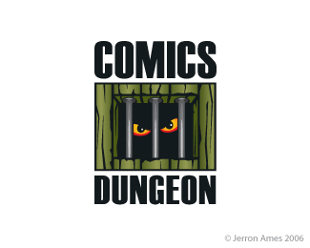
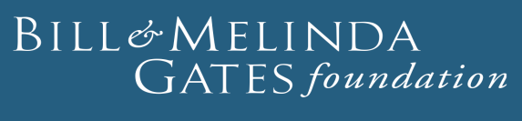
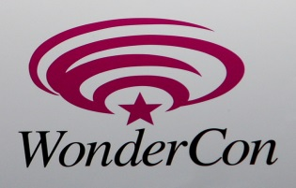

© 1996-2016 Comics4kids, Inc. 5009 50th Ave SW Seattle, WA 98136 All rights reserved.. All Logos of sponsors© 2016 used with permission.

