Comics4Kids Inc. is a Pacific Northwest based comic book reading library and national 501 (c) 3 charity. We accept comic donations, screen them, and then give them to kids for free, to improve literacy and encourage imagination as well as fostering stewardship of the collecting hobby!

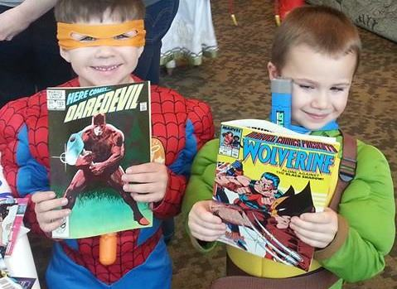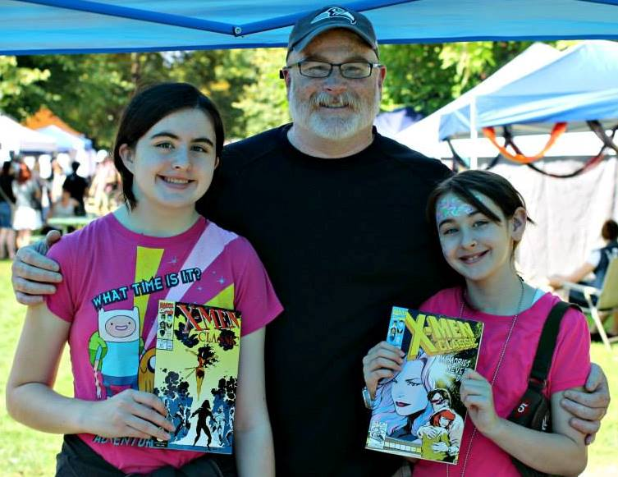
Comics4Kids Inc. gets these vetted comics into the hands of children from all ages and demographics!
We have been especially successful reaching sensory sensitives in varying stages of communicative, socio-emotional, cognitive, physical, developmental, and anti-economic trends!
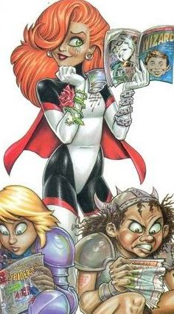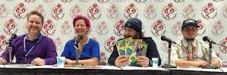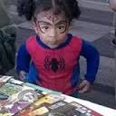
© 1996-2017 Comics4Kids INC all rights reserved. Dawn © 1989-2017 Joseph Micheal Linsner. www.Linsner.com used with permission

WE CAN’T DO IT ALONE!! Some of our AWESOME CORPORATE SPONSORS:

