www.comics-4-kids.org 206.327.7436 comics4kids@aim.com
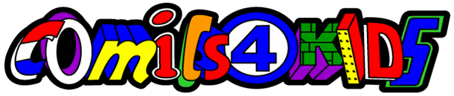

Random Sampling of Organizations that we have distributed comic books to:

Bates Technical College
Tacoma Public Library Young Readers Program
Jason Lee Middle School
Emerald City Comic Con
Half Price Books Literacy Project
International Artists Guild
Children’s Healthcare of Atlanta
Black Canyon Boys & Girls Club
CGC Forum Member ZeMan
EMDS Middle School
Casa Grande High School
City Year Little Rock
Little Heroes Inc
Rose City Comic Con
Cancer Recovery Foundation
Federal Emergency Management Agency (American Red Cross)
Jet City Comic Show
United States Armed Forces (4)
Emerald Cross
Wizard World New Orleans

Lackamas Heights Elementary

The average amount of comics sent out to families is 10-100 comic books, to schools 500 comic books, and for larger programs 1,000 to 30,000 comic books.
So far we have given away over 1,000,000 comic books!

Additionally, a great deal of private persons have requested and received comic books for their single child at home, or those attempting to learn English as second language.
All 52 United States, plus destinations in Canada, United Kingdom, and Africa have received comic books.
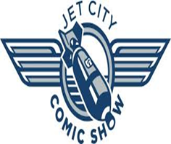
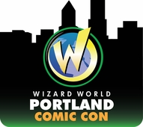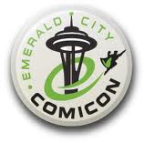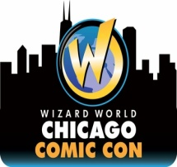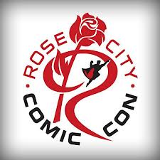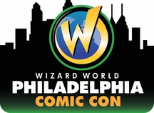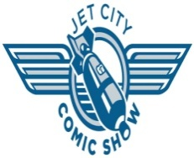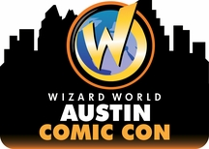
Comics4Kids © 1996- 2014 Comics4kids, Inc. All rights reserved Wizard World © 2014 Wizard World Used with Permission
Emerald City Comic Con © 2014 Emerald City Comic Con Used with Permission Rose City Comic Con © 2014 Rose City Comic Con Used with Permission Jet City Comic Show © 2014 Jet City Comic Show Used with Permission
Batman created by Bob Kane
Detective Comics & The Batman © 1939-2012 DC Comics. DC Comics does not sponsor Comics4Kids, Inc.

