T E S T I M O N I A L | Feb 12 (2 days ago)
I used to work at Kinko's, back in 2001. I remember a gentleman bringing in comics, making color copies of the covers, scanning covers - nearly every week. It was comics4kids. I also remember having a conversation with that gentleman about New Mutants - they were my favorite comics of all times, I wished I could read them again, etc. The following week he brought in a box full of them, minus only about 5 titles and gave them to me. Shocking.
This got me into a comic store in search of the missing titles. While there, I ran into other comics I used to read - She Hulk, ElfQuest, Cloak and Dagger, and I started buying these up. Then I found out that New Mutants had a new series coming out and I loved those, and I started looking at other titles - NYX, X-23, Runaways, CrossGen, etc.
I've now converted to digital - if only because I live in an excruciatingly small apartment in Korea. I'm still addicted to comics - love my Buffy and Angels! and it's completely because I was able to get my hands on those old New Mutants.
Thank you so much.
Julia

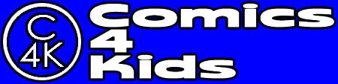
www.comics-4-kids.org (206) 327 7436 Comics4kids@aim.com

