www.comics4kidsinc.org 206.327.7436 comics4kids@aim.com
EIN 20-2882260 UBI 603-201-653

Comics4Kids, Inc. Agenda
Minutes of 08 February 2016
I. Jason McKibbin - Tacoma Office Space proposal
II. Dale Moore - DC Entertainment sponsorship, advertising 200,000 FCBD copies June 2016
Damien Moore: WonderCon March 25 26 27 2016
IV. Heidi Myrick – Bill & Melinda Gates Foundation matching gift $9800 through efforts of Chris Person from Comics Dungeon

I. Call to order
The meeting was called to order by Dale Moore, Chairman, at 10:00 AM.
In attendance were: President Dale Moore, First Vice President Heidi Myrick, Vice President Jason McKibbin, El Capitan Damien Moore, Sgt. At Arms Mason Knox, Shawna Reid, John Jensen, Gloria Reyes

II. Old Business
The Minutes of the July 9 2015 Meeting were read and approved without exception
III. New Business
Jason McKibbin, Vice President, speaking on Office Building ideas PRO Tacoma WA
Dale Moore, President, speaking on Office Building ideas CON Tacoma WA
Damien Moore, El Capitan, commenting on WonderCon 2016 (Rodd Mojica)
Dale Moore, President, announcing confirmation advertising agreement from new sponsor DC ENTERTAINMENT (Nancy Spears)
Heidi Myrick, First Vice President, addressing Bill & Melinda Gates Foundation matching gift of $9800 through efforts of Chris Person of Comics Dungeon(!!) Monies from Comics4Kids INC General Fund to be spent on travel for WonderCon 2016, Company participation fees for Seattle Pride Parade, Ethnic Fest, MAWP, Brochures, Fliers, T-Shirts, Buttons, Rubber Stamps, and comics for the kids as well as library entries!!
Round table discussion of the Highline Special Needs Resource Fair upcoming March 2016, Normandy Park, WA
Round table discussion of the Seattle Pride Parade upcoming June 2016, Seattle WA

IV. Next Meeting
The June Meeting will be held in Seattle, WA
V. adjournment
The meeting was adjourned at 2:10 PM
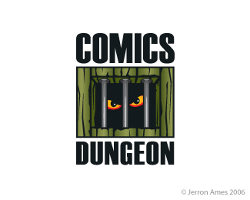

© 1996-2016 Comics4kids, Inc. 5009 50th Ave SW Seattle, WA 98136 All rights reserved.. All Logos of sponsors© 2016 used with permission.

