Comics4Kids, Inc. Agenda – Stakeholders Group
Thursday July 9, 2015

I. Spidey Myrick - Destiny City Queer Con July 11
II. Damien Moore: Atomicon July 17/8

III. Dale Moore - Ethnic Fest July 25/6, MAWP August 8th, Rose City September 19/20, and Jet City
October 31/November 1 Comic shows

IV. Spidey Myrick – State Farm gift $500 through efforts of Anne Myrick
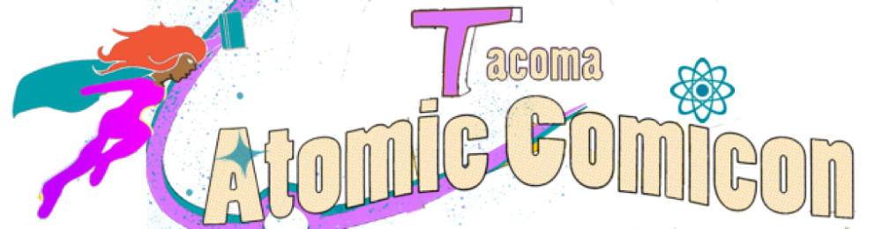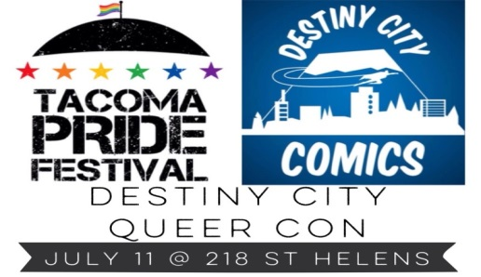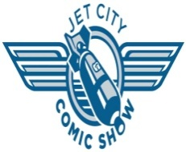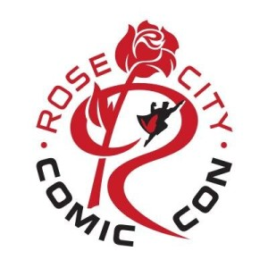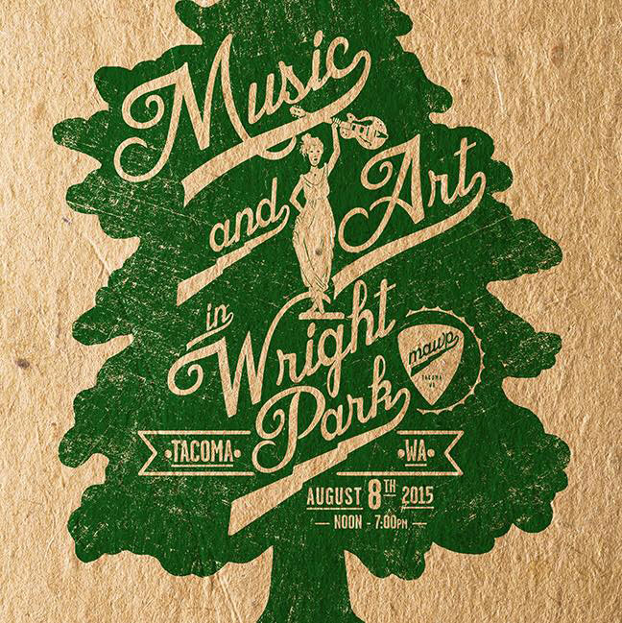

Comics4Kids, Inc. Agenda
Minutes of 09 July 2015

I. Call to order
- The meeting was called to order by Dale Moore, Chairman, at 1:00 PM.
- In attendance were: First Vice President Heidi Myrick, El Capitan Damien Moore, David Dark Cassel, Shawna Reid, John Jensen, Gloria Reyes
II. Old Business
- The Minutes of the May 5, 2014 Meeting were read and approved without exception
III. New Business
- Heidi Spidey Myrick, First Vice President, speaking on Destiny City Queer Con July 11 Tacoma WA.
- Damien Moore, El Capitan, commenting on Atomicon July 17/8 Tacoma Public Library Tacoma WA
- Dale Moore, President, announcing confirmation of tables at both Rose City Comic Con September 19/20 Portland Oregon, and Jet City Comic Show, Tacoma Washington October 31 and November 1 2015.
- Heidi Myrick, First Vice President, addressing State Farm Insurance gift of $500 through efforts of Anne Myrick of State Farm (!!) Monies from Comics4Kids INC General Fund to be spent on comics for the kids and library entries.
- Round table discussion of the Wright Park Ethnic Fest upcoming July 25/6 2015 in Tacoma, Washington
- Round table discussion of the Music and Art in Wright Park (MAWP) upcoming August 8 2015 in Tacoma, Washington
IV. Next Meeting
- The September Meeting will be held in Seattle, WA
V. adjournment
- The meeting was adjourned at 3:19 PM

