Comics4Kids, Inc. Agenda – Stakeholders Group
Monday May 5, 2014

I. Dale Moore - Lily Wright Presidential recognition for her Comics4Kids INC work!

II. Discussion Re: Wright Park Ethnic Fest, Music and Art in Wright Park, Rose City,
Jet City comic shows/conventions

III. Heidi Myrick - Public Library show in Tacoma August 9th

IV. Heidi Myrick – Comics4_Kids (Mississippi company) controversy

V. John Jensen – Transportation to Rose City Comic Con

VI. ALL – General Fund impetus: all funds to procure new additions to giveaway and
Library

VII. Shawna Reid – Details Wright Park and T-Shirt machine, bumper stickers

VIII. Damien Moore – Emerald City Comic Con recap – GREAT JOB everyone!
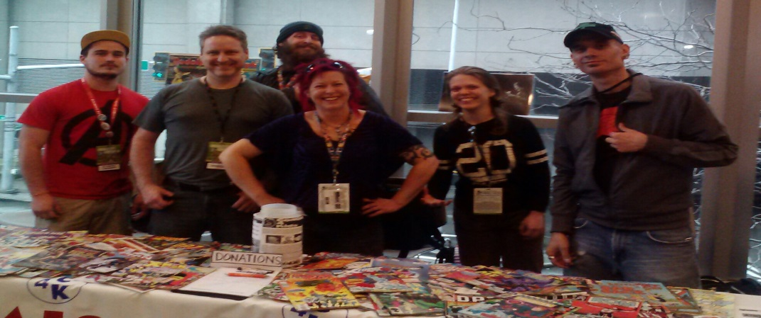

Comics4Kids, Inc. Agenda
Minutes of 05 May 2014
I. Call to order
- The meeting was called to order by Dale Moore, Chairman, at 7:00 PM.
- In attendance were: First Vice President Heidi Myrick, Dave DeShazo, El Capitan Damien Moore, David Dark Cassel, Shawna Reid, John Jensen
II. Old Business
- The Minutes of the March 16, 2014 Meeting were read and approved without exception
III. New Business
- Round table discussion of the Wright Park Ethnic Fest upcoming July 26/27 2014 in Tacoma, Washington
- Round table discussion of the Music and Art in Wright Park (MAWP) upcoming August 16 2014 in Tacoma, Washington
- Dale Moore, President, announcing confirmation of tables at both Rose City Comic Con September 20/21 2014 Portland Oregon, and Jet City Comic Show, Tacoma Washington November 8 2014.
- Lily Wright Birthday Wish for Comics4Kids INC (https://www.facebook.com/LilyWrightsBirthdayWishForComics4Kids) raised $1,164.26 cash for Comics4Kids INC! Received letter from President Barack Obama. Seattle Sounders give her Fantasy Camp/Players!
Monies from Comics4Kids INC General Fund to be spent on comics for the kids and library entries.
- Damien Moore, El Capitan, addressing recap of AWESOME Emerald City Comic Con performance by all
- Heidi Myrick, First Vice President, addressing Tacoma Public Library event August 9th 2014
- Heidi Myrick, First Vice President, addressing controversy/closure of business regarding “Comics4_Kids” named organization in Mississippi (Not us) –Popular Comic Bok writers Mark Waid and Kurt Busiek defended our legitimate Comics4Kids INC on Twitter to thousands of followers!
- John Jensen, Board Member at Large, addressing transportation to/from Rose City Comic Con
- Shawna Reid, Consultant, addressing T-Shirt making, new screen printing, T-Shirts ideas
Also popcorn machine available for Music & Art in Wright Park August 16 2014
IV. Next Meeting
- Meeting notices will be emailed to each member two weeks prior to September meeting
- The September Meeting will be held in Tacoma, WA
V. adjournment
- The meeting was adjourned at 9:14 PM

